The Evidence Supporting Therapeutic Communities:
The Other Side Academy Model

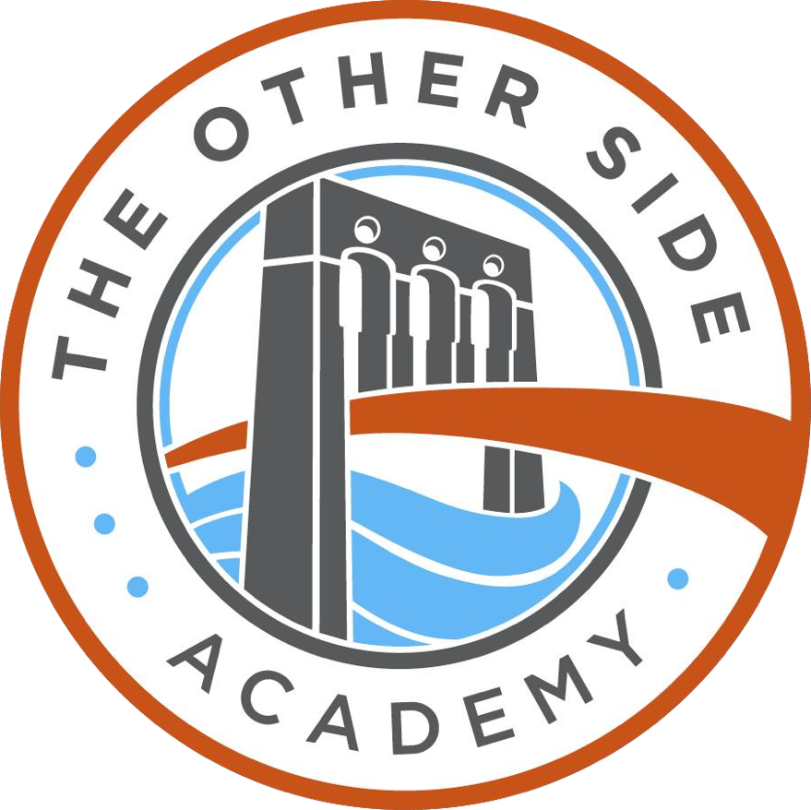

Abigail Barney
Other Side Academy Research Associate
(B.S., University of Utah 2020; J.D., University of Chicago, expected 2023).
(Created 7-30-20; Updated 3-17-21)

The Evidence Supporting Therapeutic Communities:
The Other Side Academy Model

The Other Side Academy was founded in Salt Lake City, Utah in 2015. It is a successful evidence-based therapeutic community for the treatment of substance abuse and related behavioral problems. It is a part of the Therapeutic Community tradition of treatment, and this White Paper describes the general history of these communities, their approach, their treatment methods, and their evidence-based outcomes in reducing addictions, criminal behavior, and recidivism and in increasing employability and personal success.

INTRODUCTION
The Therapeutic Community (TC) is a powerful, residential treatment for substance abuse and related behavioral problems. It is a self-help approach based on mainstream psychiatric, psychological, and medical research that has been evolving since the 1960s.
In TCs, residents change their lifestyle by identifying the root causes of their negative behaviors and by learning individual responsibility and the shared values of right living. The residents accomplish this change in a safe environment governed by a hierarchical peer structure. Residents progress through treatment stages, working and learning with community members daily. Residents become students of a new way of living. Indeed, they are specifically referred to as students in many of these programs.
Research suggests that the TC model reduces a resident’s subsequent criminal behavior and substance abuse (Aslan 2018; De Leon 2015). Additionally, the treatment model improves resident’s employment and educational outcomes and mental health symptoms (National Institute on Drug Abuse 2015). The amount of time an individual spends in the program is closely associated with positive outcomes and reduced recidivism. Table 1 conceptualizes this general process from approach to treatment methods to outcomes.

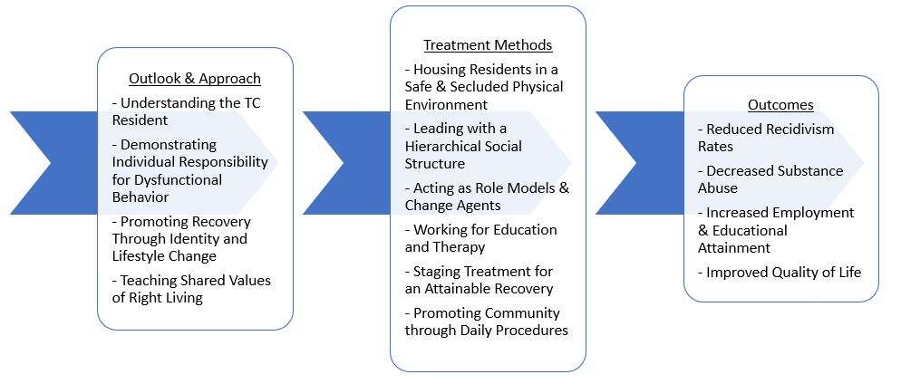
Table 1: Conceptual Framework of the Therapeutic Community Model

HISTORY
Contemporary Therapeutic Communities (TC ) treat at-risk populations through a community-based, residential treatment approach. The immediate precursors to these contemporary communities found their roots in programs developed in the 1960s and 1970s, by the Oxford Group, Alcoholics Anonymous, and Synanon (De Leon, 2000). Synanon was founded in 1958 in Santa Monica, California, and it developed the essential elements of the contemporary TC model—the perspective, the program model, and the basic methods. For more than fifteen years, Synanon thrived as an innovative treatment program, and from 1964-1971, it seeded other first-generation TCs: Delancey Street, Habilitat, Daytop Village, Gateway House, Gaudenzia, Marathon House, Odyssey House, Phoenix House, Samaritan House, and Walden House. In the following years, former students in these “parent” programs created more TCs throughout the United States, directly transmitting common elements of the original model.
Eschewing the belief that drugs are the problem, early innovators of TCs argued that long-term addiction is fundamentally a problem of disconnection. Thus, participants learned to live in a large, self-reliant family—one that demanded extraordinary levels of selflessness, honesty, humility, and mutual responsibility—as the primary therapy. The assumption is that the best way to learn to live in and connect with a healthy community is to actually live in such a healthy community for an extended time. Students learned that if they “act as if” they are a decent, honest, capable human being, then they could eventually become so (Marceau, et al 2017).
Although early TCs focused primarily on treating substance abuse, the model expanded to treat a variety of dysfunctional behaviors. This expansion of treatment modalities makes classifying a modern TC challenging. (Indeed, some treatment programs, while calling themselves TCs, do not resemble the early TC model.)
Early TCs prized self-reliance. They believed that a real community requires its members to solve real-life problems, such as generating income, cooking meals, fixing roofs, confronting freeloaders, and resolving the myriad conflicts that inevitably emerge when criminals and drug addicts run a house together. Solving real-life problems in an environment of raw and instantaneous feedback accelerated personal growth. There are reports that even thousands of non-addicts sought out TC programs when they learned of the personal grown potential created authentic TC communities.
Then, the movement lost its way. Leaders of TCs began accepting large government grants to help them accelerate their growth. With an influx of subsidies, the communities no longer needed to be self-reliant. Residents began focusing more on traditional rehab activities, such as classwork, workshop, and talk therapy. They began to act more like patients and less like community peers. Next, the government began intruding on the model itself. It demanded that TCs adopt “evidence-based” practices that were inconsistent with the community approach and pressured TCs to hire professional staff. Inevitably, the government also complained that two-years (the typical minimum stay) was too long. Soon, modified “Therapeutic Communities” emerged that were run by licensed professional staff, required only a short stay, were funded largely by outside payers, and even embraced many traditional drug treatment practices and approaches.
As such, most contemporary TCs are indistinguishable from traditional rehabs; the treatment is short, has no work component, and embraces traditional therapy. This paper focuses on the “Classic” Therapeutic Community. Some key features of a Classic TC include long-term (two or more years), institutional self-reliance, peer-run (not professionalized), and classic peer accountability systems with practices such as Pull-ups, Games, and discipline.
Today, Delancey Street, founded in 1971 in San Francisco, California, is one of the leading TC programs in the United States retaining many of the original, classic elements. With six residential education homes, the multi-state program has graduated over 18,000 students, including ex-inmates: Dave Durocher, Lola Zagey, Steve Strong, Chris Nelson, Sharon Tidwell, Beau Clark, and Robert Davalos (The Delancey Street Foundation, 2007; The Other Side Academy 2021). In 2015, Joseph and Celia Grenny along with Tim Stay partnered with Delancey graduates to bring the TC model to Utah.
Since its inception, The Other Side Academy has grown to multiple campuses and established a track record of efficacy in helping students achieve sober and productive lives. Other existing TCs that practice the classic approach include Habilitat in Hawaii, TROSA in North Carolina, Red Barn Academy in Utah, and San Patrignano in Italy.

OUTLOOK & APPROACH
The Therapeutic Community (TC) model is rooted in a unique and explicit perspective of the TC participant, dysfunctional behavior (including substance abuse), recovery, and right living. The following elements are what have jointly contributed to its evidence-based effectiveness.

Understanding the Therapeutic Community Student

Although TC students differ in demographic, social, and psychological backgrounds, most share characteristics of the disordered person. Table 2 displays the cognitive and behavioral, perceptual, emotional, and social characteristics common of incoming TC participants. These characteristics often present themselves in similar behavior patterns: deception or manipulation of others, procedures, and systems; criminal activity or legal problems; and dysfunctional behavior, including substance abuse (Aslan and Yates 2015).

Table 2: Common Characteristics of Therapeutic Community Participants
De Leon, 2000; pg. 49-64

Cognitive and Behavioral | Perceptual | Emotional | Social
Poor awareness | Negative perception of self | General problems of maturity | Sense of entitlement
Poor judgment | Low self-esteem | Low threshold for emotional cues | Irresponsible
Difficulties in decision-making | Negative identity | Limited repertoire for emotional communication | Lack of trust
Lack of problem-solving skills |  | Few behavioral boundaries | Inconsistent
Lack of educational and/or vocational skills |  | Lack of emotional self-management | Unaccountable

Other treatment models focus on the drug, not the person, when treating substance abuse and related problems (Best and Haslam 2016). These models see substance abuse as the root cause of other dysfunctional behavior, whereas the TC model sees substance abuse as the symptom of a larger problem with the whole person. By understanding that substance abuse and dysfunctional behaviors both rise from varied biopsychosocial sources, the TC program and its structure fit the recovery needs of the individual.

Demonstrating Individual Responsibility for Dysfunctional Behavior
In the TC perspective, “social and psychological factors are recognized as the primary source” of dysfunctional behavior (De Leon, 2000). Similar factors contribute to most TC student’s poor behavior patterns: socio-economic disadvantage, ineffective parenting, family dysfunction, negative role models, deviant social learning, and early oppositional personality traits (De Leon, 2000). Although TCs recognize these factors as an important part of illuminating the individual’s social and psychological history, they are at least partially out of the individual’s control. Therefore, instead of focusing on these factors, the TC model emphasizes the individual’s contribution to past problems. A fundamental element of the perspective, therefore, is that recovery is always the responsibility of the individual, regardless of the source of the dysfunctional behavior.
The TC perspective is consistent with current biomedical research on substance abuse—it’s just that the focus of each perspective is simply different. The biomedical perspective on physical dependency (evidenced by escalating tolerance for a drug of choice and characteristic withdrawal symptoms) focuses on addiction as a biological or mental disease. Conversely, the TC model focuses on addiction as a social and psychological disorder: physical dependency that describes the continuous behavioral, cognitive, and emotional preoccupation with drug use. In this view, addiction is a symptom, not the underlying problem (Marceau, et al. 2017).

Promoting Recovery Through Identity and Lifestyle Change
In the TC perspective, a student who is living in a TC environment will change their identity and lifestyle. The process of living in these environments will target negative characteristics and replace them with positive ones. By changing their identity and lifestyle, students recover. This contrasts with how other treatment methods approach recovery. These other models (such as a therapy approach) view addiction as a chronic disease and, therefore, view recovery as extending periods of abstinence—not addressing deeper deficits of the whole person.
In the TC perspective, self-help and mutual self-help are the key requirements for recovery to occur. Self-help means that individuals make the main contribution to the change process (Dingle 2019). The model and methods of the TC help a student recover, but ultimately the effectiveness of these methods depends on the individual. A desire to change and a commitment to the recovery process is necessary for success within a TC. Mutual self-help refers to the process in which individuals also assume responsibility for the recovery of their peers to maintain their own recovery. Although a student is responsible for their own recovery, other recovering students are importantly useful in help promote change this change in the individual. The social context of the TC enforces this concept through a commonly held view of right living.

Teaching Shared Values of Right Living
“Right living” refers to the shared assumptions and beliefs of what constitutes healthy personal and social living. Each TC emphasizes specific values that are essential to right living and constantly reinforces them through various formal and informal means. These apply in all situations and for all people. For example, Table 3 summarizes The Other Side Academy’s values of right living, which contain values common among Classic TCs. These values (and a short description of them) are prominently posted around the facility and are continuously emphasized in all activities.

Table 3: The Other Side Academy’s Primary Values of Right Living

1. You alone can do it, but you can’t do it alone. | 7. Each one teach one.
2. Make & keep promises. | 8. 200% accountability.
3. Self-reliance. | 9. Forgiveness.
4. Impeccable honesty. | 10. Boundaries.
5. Act as if. | 11. Faith friendly.
6. Embrace humility. | 12. Pride in work.

TREATMENT METHODS
The TC method is its social and psychological environment. Each component of the environment reflects an understanding of the TC’s perspective and promotes community values and self-change (Neale, Tompkins, and Strang 2018). This approach is often summarized in the phrase “community as method.” This section will briefly describe the essential components of the method: the physical environment, the social organization, the roles of staff and peers, the work, the program stages, and the daily procedures.

Housing Students in a Safe & Secluded Physical Environment
Within the TC model, a complete “detoxification” from the outside world is an essential first step in the recovery process. For this to occur, the TC seeks to maintain a physical and social separateness from the setting in which it is located. Not only does this physical and social distance allow the student to detach from the negative people, places, and things previously associated with their dysfunctional behavior, it also fosters affiliation with the new community (Dingle, et al. 2019).
Similarly, the physical characteristics of TC facilities and grounds are designed to reflect the TC recovery process. First, TCs are not locked facilities. Instead, they are semi-closed environments with restricted access. Student’s whereabouts are consistently monitored, but the fact remains that a student could leave at any time. This promotes the sense of personal choice within the community. Second, TCs have multiple common spaces that allow for educational and therapeutic activities, including a dining room, a lounge, and sometimes a classroom. Each area is designed to foster a different type of social activity (i.e., communal dining, informal chatting, group seminars). Third, TC sleeping quarters range from semi-private to private rooms. Living and sleeping in an open community promotes peer solidarity and discourages personal isolation, and, in TCs, privacy is a privilege. Thus, new students share dormitories with two to five other students. As a student progresses through the program, they may move into private rooms or be allowed to decorate their semi-private spaces with approved accessories.

Leading with a Hierarchical Social Structure
Unlike in other institutional or residential treatment settings, the social environment of the TC is the treatment model. Within the model, community status and job assignments create a clear hierarchical structure of authority, with staff and senior students at the top and new students at the bottom. The clear structure allows staff to make all major decisions, while also allowing students to have considerable informal authority. Students gain this informal authority as they progress through the program stages. Providing a clear path for upward mobility within the TC helps those with a history of performance problems maintain focus.
The clear structure also promotes positive communication within the TC, both formally through mandatory reporting chains and informally through student interactions. Formal communication is necessary for the smooth functioning of the organization and the individual treatment process. A breakdown in the formal communication process could result in negative behaviors being reinforced by neglect. Similarly, informal communication between students promotes assimilation into the community and disseminates relevant information throughout the TC.

Acting as Role Models & Change Agents
With few exceptions, the staff in a TC are individuals who themselves went through the recovery process. “As role models of lifestyle change, they qualified as authorities and guides in the change process” (Haigh and Pearce 2017). Therefore, they are equal to the students because they are people involved in a personal change process, but they are unequal because they are further along in their process.
The functions of the staff can be broadly grouped into four categories: facilitator, informal counselor, community manager, and rational authority. Staff members understand that recovery requires internalized learning that can only be accomplished through direct personal experiences. Therefore, as a facilitator, they arrange and foster situations that can result in learning opportunities. As an informal counselor, they attend to an individual’s specific needs, ensuring students do not become invisible within the group. As a community manager, staff oversee all activities within the TC: the physical operations, clinical programs, and daily regimen. Finally, as rational actors, staff make all decisions concerning the status of individuals in the community. Staff provide explicit reasons for their actions and follow up with their decisions to determine whether students understand and accept them. While not the case at all TCs, the staff at The Other Side Academy live on campus.
Peers are the primary change agents within the TC (Neale, Tompkins, and Strang 2018). In the TC perspective, positive peer culture needs to be consistently maintained to counter past or current negative peer influences. The main functions of peers within the community are broadly defined as community managers, siblings, and role models. As community managers, peers observe the behavior of other students and provide clear feedback to facilitate the process of change. Peers do this through “pull-ups,” “push-ups,” and “pulling-in others.” As siblings, peers teach one another to concern and care for others, as it is in a healthy family. Finally, as role models, peers train and tutor one another through the process of recovery. Senior students, who are near the top of the social hierarchy, show others how to change. This mentorship not only helps others learn but also reinforces positive self-learning.
It is important to note that, although students are encouraged to build relationships with peers in the community, romantic relationships and “cliques” are not allowed in TCs. In order the ensure these relations are avoided, students are constantly monitored, private facilities are separated by gender, and members of groups are encouraged to branch out. Furthermore, relationships with people outside the TC are put “on hold” while an individual is in treatment. This disconnection removes students from negative influences and facilitates assimilation within the community.

Working for Education and Therapy
Other treatment methods assume treatment is needed before the individual can return to or learn to work. In the TC model, however, work is an essential component of treatment (De Leon, 2015). Work is considered a necessity to a healthy and productive lifestyle; however, being able to work consistently and responsibly requires marketable skills and adherence to values of right living. Thus, work in the TC teaches marketable skills and produces therapeutic change.
TC work programs make students employable. The work program teaches students basic marketable skills that prepare them for entry-level jobs (sometimes professional jobs) or further training programs when they leave the TC. For instance, at The Other Side Academy (TOSA), students can participate in multiple internal and external training programs. The internal work programs sustain the daily operations of the program: bookkeeping and accounting, food services, construction and maintenance, legal and intake, business development, and cleaning services. External work programs generate revenue for the TC: a moving company, a thrift store, construction services, and others. Secondly, the work program teaches personal habits needed to sustain a job outside the TC, including “wake-up habits, appropriate dress, language, punctuality, resilience, ability to pay attention and follow instructions, and emotional management related to receiving criticism and compliments as well as giving and following orders” (De Leon, 2000). The demanding work environment allows staff to identify behaviors and attitudes that need addressing. It also gives students a chance to test their newly developed changes and challenges them to continue changing in a safe, real-world environment.
The financial self-sufficiency generated through work programs also benefits the TC. The requirement to maintain financial self-sufficiency enhances feelings of pride in work and self-respect. Students, possibility for the first time, provide for their own needs. Likewise, by being self-sustaining, the program can maintain the integrity of its design rather than succumb to inevitable pressures by funding organizations, such as shortening treatment or following therapeutic fads. For this reason, The Other Side Academy does not accept government, insurance, or personal money. Instead, external training programs generate revenue to cover program expenses.

Staging Treatment for an Attainable Recovery
In the TC, program stages are prescribed points of expected change. For most new students, lifestyle and identity change are abstract concepts. The program stages, therefore, define concrete attainment markers to guide the change process (De Leon, 2015). The division of long-term goals into shorter-term goals helps the process feel more tangible and attainable. In this section, each program stage will be discussed individually: recruitment, orientation, primary treatment, re-entry, graduation, and aftercare.

Recruitment
Therapeutic Communities have different requirements for admission, and part of these requirements contribute to them having high evidence-based effectiveness. For instance, to be eligible to be admitted to The Other Side Academy, an individual must be between the ages of 18 and 65 and be physically capable of operating in a high-paced, physically demanding environment. He or she must also be ready to make a 2.5-year commitment to change—the most important requirement. Additionally, TCs generally do not accept sex offenders, arsonists, applicants with murder charges, applicants with assaults on police officers, and applicants with “dual diagnosis.”
There are two typical ways to join a TC. At The Other Side Academy, the first way is to come in, sit on the “Bench,” and ask for an interview. Those who walk into the TC and ask for an interview could be those recently released from incarceration, homeless individuals, or addicts. A staff member and some other members of the community interview the prospective student to see how serious they want to change their life.
The Bench is an important artifact for many TCs. It sits right at the entrance of the house: everyone coming in and coming out of the house must pass it. The Bench has several meanings for the community. For one, the bench symbolizes the portal into and out of the community. If an individual wants to join the community, he or she must sit on the Bench. Likewise, if a student breaks a major rule of the community, he or she must sit on the bench to see if remaining in the community is possible. The Bench also symbolizes the openness of the community. Anyone who wants to change can sit on the bench and ask for help. It does not matter if he or she has money, government aid, or insurance. The Bench is available twenty-four hours a day, seven days a week for new students to sit down and ask to join the community.
Prospective residents may also write a letter from jail, asking to be accepted into the TC. Most students come to The Other Side Academy community through this method. After the individual writes from jail, TC staff will set up an interview at the jail to determine if the applicant will fit into the community. The interview tests if an applicant is truly ready and willing to change their life. It weeds out those manifestly unsuitable for the TC and prepares others for long-term residential treatment (Palmer 2013). If the interviewer feels that the candidate genuinely wants to change, the candidate will receive an acceptance letter, which the judge and attorneys can use to divert the case. If the judge accepts the letter, the student may be able to be a TC community member as an alternative to incarceration (“How to Apply”).
Once accepted into the program, students must complete an intake form, which gives staff important information about their background, current finances, and physical health.

Orientation
The length of orientation varies between two weeks and three months of residency. The primary goal of this stage is to assimilate the individual into the community (Clark and Waring 2018). Informal orientation occurs when peers guide the new student around the facility, explain the rules, and introduce them to other students.
Formal orientation occurs when assigned mentors, senior students, or staff members teach the new student the rules of the community and explain what to expect in the coming months and years. During this phase, new students have limited freedoms and his or her movements are typically restricted to the campus.

Primary Treatment
In most TCs, primary treatment consists of two to four subphases. For instance, at The Other Side Academy, a student progresses through four stages during primary treatment: freshman, sophomore, junior, and senior. The goal of primary treatment is to accomplish socialization into the community, personal growth, and psychological awareness though the TC activities and resources (Clarke and Waring 2018). The freshman stage generally lasts two to four months and is characterized by basic life-skills and vocational training, household chores, and team-building activities. The sophomore, junior, and senior phases generally last from month four to month twenty-four of a student’s treatment. During these phases, students work at one of the training programs and continue participating in all community activities while assuming significant leadership roles for the house. Students are given additional privileges, responsibilities, or duties as they progress through these stages.

Re-entry
The re-entry phase generally takes place during the last three to six months of treatment. The primary goal of this stage is to facilitate an individual’s detachment from the community and complete their successful transition back to society (De Leon, 2000). During this phase, students begin deciding what they want to do after graduation and taking steps to get there.
At The Other Side Academy, this period is referred to as the “Work-Out” phase. These students live on campus, gain outside employment, and reengage with family and the community, all while receiving significant coaching and support from staff and students. During this phase, TC resources help with debt consolidation, career planning, relationship management, and parenting challenges.

Graduation & Aftercare
Students who complete all thirty months of treatment are eligible for graduation. Graduates are drug-free, have a job or student status, and have resolved circumstantial impediments (Mitchell, Wilson, and MacKenzie 2007). At The Other Side Academy, students have the option of staying an additional year or more if they feel like they are not ready to reenter society. The financial self-reliance of The Other Side Academy allows the student to make re-entry decisions based on his or her needs rather than financial considerations.
Similarly, aftercare is a major goal of many TCs (Haley, et al 2018). First, many programs allow students to “ease out” of the program at their rate, making sure they are ready for successful reentry. Second, TCs provide students with resources to make the transition from the community to society as smooth as possible. Finally, TC staff stay in contact with graduates to ensure they are staying on a positive path and to encourage them to come back to the TC periodically to be an example to other students.

Promoting Community through Daily Procedures
The day-to-day activities in the TC are guided by clearly defined activities, rules, and procedures. These include community and therapeutic meetings, house rules enforced through privileges and sanctions, and safety and security procedures. “In the TC, all activities, planned and unplanned promote recovery and right living. However, planned activities are viewed as interventions or methods,” designed to impact the general community and the individual (De Leon, 2013). As such, the TC community utilizes four types of community-wide meetings, three of which take place every day. Table 4 summarizes the main components of each meeting.

Table 4: Main Community-Wide Meetings
(De Leon, 2000; pg. 251)

 | Morning | Seminar | House | General
Purpose | Initiate positive outlook; motivate participation | Teach concepts of the TC perspective; train conceptual and communication skills | Manage community business; disseminate information | Address community-wide problems; affirm community cohesion
Frequency | Daily | Daily | Daily | As needed
Duration | 30-45 minutes | 60-90 minutes | 45-60 minutes | Open-ended
Composition | All peers and select staff | All peers and select staff | All peers and all staff | All peers and all staff
Staff Role | Preparation with peers; voluntary participation | Preparation; oversight; selective implementation | Preparation; oversight; selective implementation | Preparation; oversight; implementation
Peer Role | Preparation; implementation by peer teams | Preparation; implementation by select peers | Preparation; implementation; highest-ranking peer | Senior peers assist staff

Similarly, the TC facilitates positive change in the individual through three types of clinical meetings: 1) Basic Encounter or Game meetings, 2) Probes or Sophomore Retreats, and 3) Marathons or Junior Retreats. Table 5 summarizes the main components of each meeting.

Table 5: Main Therapeutic Community Clinical Groups
(De Leon, 2000; pg. 276)

 | Basic Encounter or Games | Probes or Sophomore Retreat | Marathons or Junior Retreat
Stage | 1-24 months | 4-7 months | 12-18 months
Frequency | 2/week | Once per student | Once per student
Duration | 2 hours | 12 hours | 24-30 hours
Composition | A staff member or senior student facilitates group process; 10-20 students | Staff members lead/facilitate group process; 4-6 students | Staff lead, direct, and facilitate group process; 10-12 students
Objectives | Raise awareness of specific behaviors/attitudes | Obtain information on critical life events; preparation for marathons; surface emotional memories | Initiate resolution of critical life events through profound emotional reliving
Approach/Techniques | Verbal: confrontation of daily behavior and attitude by affected community members | Verbal; supportive inquiry of sensitive life experiences and occasional confrontation of detachment or distorted views of self or others | Verbal supportive inquiry of sensitive life experiences at a greater level of specificity than Probe. Use of role-playing and psychodrama to enhance insight and affect.

TCs have explicit rules that define behavioral boundaries within the community. For instance, Table 6 displays the major house rules at The Other Side Academy, which have been organized into three categories of strictness. Privileges and sanctions ensure students abide by these house rules and meets the community’s expectations. Privileges build community, promote individual socialization and personal growth, and facilitate goal attainment. On the other side, sanctions are also clinical interventions. They raise a person’s awareness of the personal and social consequences of their behavior, and they help to condition more acceptable behaviors.

Table 6: Cardinal, Major, and House Rules
(De Leon, 2000; pg. 224)

Cardinal Rules
No physical violence, threats of physical violence, or intimidation against any person
No drugs, alcohol, or related paraphernalia
No sexual acting out, including romantic or sexual physical contact
Major Rules
No stealing or other criminal activity
No vandalizing or destroying property
No contraband or weapons
House Rules
Acceptance of authority (listening and behaving)
Punctuality (being on time)
Appropriate appearance
No impulsive behavior
Proper manners
No lending or borrowing
No receiving gifts without staff permission

In the TC, the actions of individuals and the facilities are constantly monitored for safety and security. Clear processes for ensuring the safety of all students include daily inspections and drug testing. Inspections are thorough reviews of the safety and cleanliness of the house. Several times a day, a group of staff and senior students walk through the entire facility to ensure daily health and safety of students, as well as to detect potentially larger problems early. Similarly, the TC conducts drug testing randomly or procedurally after suspected drug use. Unannounced testing is a way to keep students accountable and the community safe.

RESEARCH ON THERAPEUTIC COMMUNITIES

The Therapeutic Community Process is an Evidence-Based Treatment
Decades of research has demonstrated that the TC model is an effective and cost-effective treatment option for particular subgroups of the population. The model, being complex and all-inclusive, has been challenging to research. However, major outcome studies, control studies, statistical meta-analyses, and econometric studies have produced compelling evidence. Similarly, individual TCs recently embraced data collection unlike in the past, that, over time, will add to existing knowledge about the model. Likewise, in recent years, researchers have looked more closely at certain elements of the TC and embraced new methods of analysis.
The aggregate evidence produced through this research confirms that the TC is an effective treatment model. Moreover, a study by Mitchell, Wilson, and MacKenzie concluded that, at this point, TCs have the strongest level of empirical support of any treatment aimed at chronic criminal-addicts.
Some of the key findings from current research are summarized in this section. These include population-based evidence and major outcome-based evidence. A consistent finding throughout all the major studies—the amount of time spent in treatment is related to success—is also discussed.

Who do Therapeutic Communities Treat?
Major research projects have identified the characteristics and demographics of those who have completed TC programs. Many studies show that TC students who are admitted struggle with a number of problems that accompany severe substance use – such as social deviance and psychological symptoms (Harley, et al 2018). Other research has suggested that nearly three-fourths of participants have a non-drug-related psychiatric disorder in addition to substance-related problems upon entering the TC (National Institute on Drug Abuse 2015). In other words, individuals with severe dysfunctional behavior are those who enter Therapeutic Community programs. They also frequently have histories of multiple drug abuse, including illegal drugs along prescription medications.
Of those who have participated in a TC, nearly 70% are male; however, the number of females entering TCs increased in recent years (Best, et al 2018). Additionally, most contemporary TCs integrate across race and ethnicity; although, “demographic proportions differ according to geographic regions and specific programs” (De Leon, 2013). Gender and race proportions within a TC generally reflect the demographics of the incarcerated population in the surrounding geographic region.
Research also revealed that approximately one-third of TC students have a compromised legal status. This status can be court-ordered, paroled, or probated (Haigh and Pearce 2017). At The Other Side Academy, roughly 80% of students participate in the program as an alternative to jail or prison, and approximately 20% walk in from off the street, with no time suspended over them.

What is the Retention Rate?
Rates of first-month attrition in outpatient (non-methadone) substance abuse treatment programs are approximately 30%, and drop-out before 3 months can be 50% or more (Palmer, 2013). According to data published by The Other Side Academy, the retention rate for a 2+ year program that is as good or better than these shorter 90-day substance abuse treatment programs. Among those students who committed to two year of treatment, 51% of them completed the program. Most students who drop-out will drop out within the first two weeks of treatment.

What are the Outcomes?
A large body of research exists that focuses on the outcomes of those who participate in TC programs (See Figure 1). Overall, these studies have found that TC participants show improvements in criminal behavior, substance abuse, and mental health symptoms (De Leon, 2013; National Institute on Drug Abuse 2015; Vanderplasschen, 2013; Pearson & Lipton, 1999). One of the most rigorous addiction recovery studies ever conducted, Dr. George DeLeon found that 88% of those who completed a 2-year stay at Daytop were employed, crime-free, and completely abstinent five years later (De Leon 2015). Successive studies gave credence to the idea that focusing on “whole person change” rather than simply getting off drugs was substantially more effective for the chronic criminal-addict (Martin, et al. 1999).

Figure 1: Summary of Selected Outcome Studies
(DeLeon, 2010)
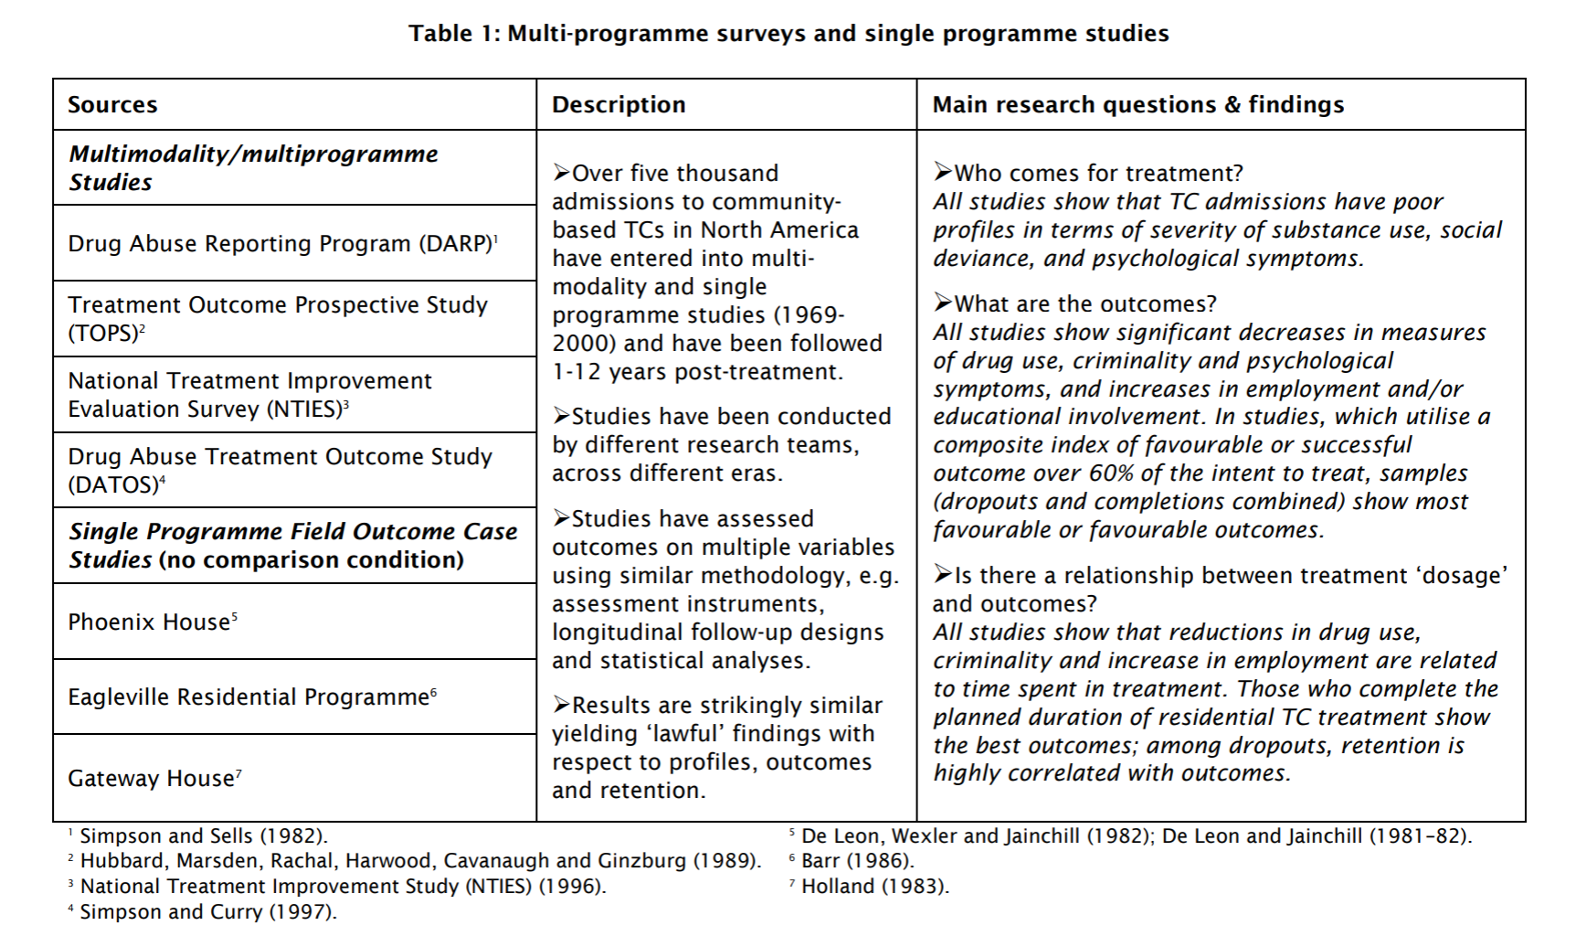

Additionally, employment outcomes, educational involvement, risk behavior, and family and social relationships all showed improvement within the TC model— especially for participants who enter treatment with the most severe problems (Vanderplasschen, 2012). A 2005 National Institute on Drug Abuse study found that 72% of participants in the California Amity TC aftercare program were employed five years after completing the program, compared to 56% of those who completed the TC program without aftercare and 40% of those who did not complete the TC program (Wexler & Prendergast, 2010).

Length of Program is Critical
The length of time in a TC program was found to be important in all studies of the model. Those who spend the most time in treatment, show the best reductions in drug use, decreases in criminality, and increases in employment (De Leon, 2013; National Institute on Drug Abuse 2015). Likewise, those who participated in TC treatment for at least three months showed better outcomes at one year, and those who completed the planned duration of treatment program show the best outcomes (Vanderplasschen, 2013). Figure 2 demonstrates these trends in the context of a 1984 study on TC participants who were primarily opioid abusers. An additional study found that “[a]mong participants in TCs, better 5-year outcomes (such as reduced cocaine, marijuana, and problem alcohol use and illegal activity and increased full-time employment) were associated with remaining in treatment for 6 months or longer” (National Institute on Drug Abuse 2015).
Therapeutic Communities are unique in that students stay in treatment for a long time: two or more years. Typical treatment programs run for 30, 60, or 90 days. These programs often do not provide students with enough time to make substantial identity and lifestyle change, are therefore not as effective as the TC model.

Figure 2: Success Rates in a Therapeutic Community by Months in Treatment
(DeLeon, 2010 from DeLeon, 1984)
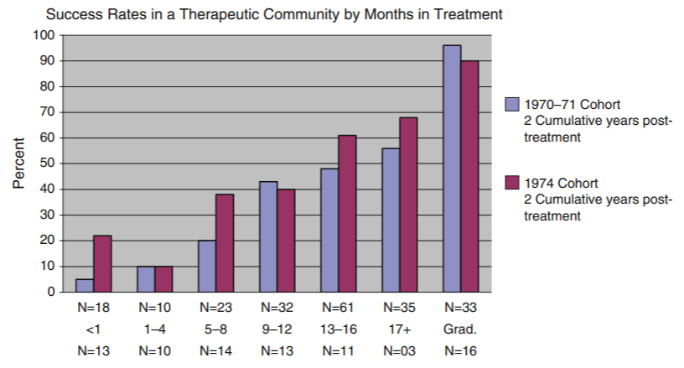
BENEFITS OF THERAPEUTIC COMMUNITIES OVER OTHER METHODS
With so many treatment options available, the best treatment option depends on the individual circumstances of the patient. Some people respond better to residential treatment, while others need a more individualized approach. Every treatment method has advantages and disadvantages, as summarized in Table 7 below.
Therapeutic Communities have a unique set of advantages and disadvantages. Therapeutic Communities are designed for individuals that have a desire to change and are led by former students who have completed the program. These methods promote the type of community the model seeks to build, but these may not be right for everybody. Likewise, the model utilizes techniques from individualized and group counseling, residential services, and vocational training to change students’ lives. Therapeutic Communities seek out the type of patients that will utilize all these resources.

Table 7: Advantages and Disadvantages of Treatment Methods
(Deeds, 2015)

Model | Method | Advantages | Disadvantages
Individual Counseling | Involves one-on-one meeting with a counselor | - Work at own pace | - Self-motivation is necessary  - Possibly continues to be in an unhealthy environment  - Discovery of “why” does not translate in to “how” to change
Recovery Meetings (AA, NA) | Peer support groups | - Widespread  - Group support  - Sponsor for individual support | - Non-professional environment  - Possibly continues to be in an unhealthy environment
Outpatient Treatment | Counseling groups that meet multiple times a week | - Group support  - Individual support (sometimes)  - Stay employed and with family | - Confidentiality cannot be completely protected (relies on other group members)  - Possibly continues to be in an unhealthy environment
Medication-Assisted Treatment | Uses medication as a replacement for those addicted to opiates | - Physical and emotional stability for the patient  - Usually paired with individual or group counseling | - Long-term treatment, possibly even indefinite  - Abuse of the medication is possible  - High overdose rates
Inpatient Treatment | Conventional rehab—24-hour treatment at a residential facility | - Intensive treatment  - Safe environment | - Large time commitment  - Low success rates
Halfway House | Community of addicts and/or those released from incarceration  *generally used as an aftercare option | - Social reintegration  - Access to services (vocational training, education, medical and dental assistance)  - Safe environment | - Large time commitment  - Possibly continues to be in an unhealthy environment
Therapeutic Communities | Self-sustaining, uniquely structured community of addicts and/or those with a criminal history | - Intensive Treatment  - Safe Environment  - Individual and group support  - Access to services (vocational training, education, medical and dental assistance)  - Phased recovery | - Large time commitment  - Non-professional environment  - Self-motivation is necessary

CONCLUSIONS
The Therapeutic Community (TC) is a residential treatment for substance abuse and related behavior problems associated with successfully living in society. Therapeutic Community students change their lifestyles by identifying the root cause of their negative behaviors, learning individual responsibility, and living by shared values of right living. The students accomplish this change in a safe environment governed by a hierarchical peer structure, progressing through treatment stages and working with community members daily.
Evidence-based research shows that this model appears effective in reducing criminal behavior and substance abuse (Yates 2010). “To date, the TC remains superior to other forms of drug treatment in reducing recidivism and drug relapse amongst addicts who offend” (Aslan, 2018). Multiple studies found that focusing on change of the whole person over an extended period produces lasting positive effects on TC students (De Leon, 2010).
Likewise, the model is successful in improving employment, educational outcomes, and mental health symptoms (National Institute on Drug Abuse 2015) as well as reducing recidivism (Mitchell, Wilson, and MacKenzie 2007). The amount of time an individual spends in any treatment program is closely associated with positive outcomes and reduced recidivism. Therapeutic Community’s long treatment duration, therefore, improves outcomes for students.

References

Aslan, L. & Yates, R. (June 2015). Exploring the “black-box” of therapeutic community (TC) methodology and the subjective experiences of students within TC structures. Therapeutic Communities: The International Journal of Therapeutic Communities, Volume 36, Issue 2.
Aslan, L. (April 2018). Doing Time on a TC: how effective are drug-free therapeutic communities in prison? A review of the literature. Therapeutic Communities: The International Journal of Therapeutic Communities, Volume 39, Issue 1.
Barreno, E. M., Domínguez-Salas, S., Díaz-Batanero, C., Lozano, Ó. M., Marín, J. A. L., & Verdejo-García, A. (2019). Specific aspects of cognitive impulsivity are longitudinally associated with lower treatment retention and greater relapse in therapeutic community treatment. Journal of substance abuse treatment, 96, 33-38.

Best, D. & Haslam, C. (September 2016). Social networks and recovery (SONAR): characteristics of a longitudinal outcome study in five therapeutic communities in Australia. Therapeutic Communities: The International Journal of Therapeutic Communities, Volume 27, Issue 3. https://www.emerald.com/insight/content/doi/10.1108/TC-04-2016-0012/full/html.

Bloor, M., McKeganey, N., & Fonkert, D. (2018). One Foot in Eden: A Sociological Study of the Range of Therapeutic Community Practice (Vol. 5). Routledge.

Best, D., Vanderplasschen, W., Van de Mheen, D., De Maeyer, J., Colman, C., Vander Laenen, F., ... & Nagelhout, G. E. (2018). REC-PATH (Recovery Pathways): Overview of a four-country study of pathways to recovery from problematic drug use. Alcoholism Treatment Quarterly, 36(4), 517-529.

Caputo, A. (2019). The experience of therapeutic community: Emotional and motivational dynamics of people with drug addiction following rehabilitation. International Journal of Mental Health and Addiction, 17(1), 151-165.

Clarke, J. & Waring, J. (June 2018). The transformative role of interaction rituals within therapeutic communities. Sociology of Health & Illness, Volume 40, Issue 8. https://onlinelibrary.wiley.com/doi/full/10.1111/1467-9566.12773.
Debaere, V. & Verhaeghe, P. & Vanheule, S. (September 2017). Identity change in a drug-free Therapeutic Community: a Lacanian interpretation of former residents’ perspectives on treatment process and outcome. Therapeutic Communities: The International Journal of Therapeutic Communities, Volume 38, Issue 3.
Deeds, A. (2015). The Pros and Cons of Different Addiction Treatment Options. Addiction Treatment. https://www.choosehelp.co.uk/topics/addiction-treatment/the-pros-and-cons-for-different-treatment-options-for-addiction.
Delancey Street Foundation. (2007). http://www.delanceystreetfoundation.org/accomplish.php.
De Leon, G. (2000). The Therapeutic Community: Theory, Model, and Method, Springer Publishing: New York.
De Leon, G. (January 2010). Is the Therapeutic Community an Evidence Based Treatment? What the Evidence Says. International Journal for Therapeutic and Supportive Organizations.
De Leon, G. (2013). “Therapeutic Communities” in Interventions for Addiction, Volume 3, editor Peter M. Miller, Amsterdam: Elsevier.
De Leon, G. (September 2015). “The Gold Standard” and Related Considerations for a Maturing Science of Substance Abuse Treatment. Therapeutic Communities; A Case in Point. Substance Use & Misuse, Volume 50, Issue 8-9.
Dingle, G. A., Haslam, C., Best, D., Chan, G., Staiger, P. K., Savic, M., ... & Lubman, D. I. (2019). Social identity differentiation predicts commitment to sobriety and wellbeing in residents of therapeutic communities. Social Science & Medicine, 237, 112459.

Harley, M., Pit, S. W., Rees, T., & Thomas, S. (2018). Completion rates and psychosocial intervention effectiveness in an Australian substance use therapeutic community. Substance abuse treatment, prevention, and policy, 13(1), 1-11.

Haigh, R., & Pearce, S. (2017). The theory and practice of democratic therapeutic community treatment. Jessica Kingsley Publishers.

Marceau, E. M., Berry, J., Lunn, J., Kelly, P. J., & Solowij, N. (2017). Cognitive remediation improves executive functions, self-regulation and quality of life in residents of a substance use disorder therapeutic community. Drug and alcohol dependence, 178, 150-158.

Martin, S., Butzin, C., Saum, C., & Inciardi, J. (1999). Three-Year Outcomes of Therapeutic Community Treatment for Drug-Involved Offenders in Delaware: From Prison to Work Release to Aftercare. The Prison Journal, Volume 79 Issue 3.
Mitchell, O., Wilson, D., & MacKenzie, D. (2007). Does incarceration-based drug treatment reduce recidivism? A meta-analytic synthesis of the research. Journal of Experimental Criminology, 3(4), 353-375. https://doi.org/10.1007/s11292-007-9040-2.
National Institute on Drug Abuse. (July 2015). Therapeutic Communities Research Report. https://www.drugabuse.gov/publications/research-reports/therapeutic-communities.
Neale, J., Tompkins, C. N., & Strang, J. (2018). Qualitative exploration of relationships between peers in residential addiction treatment. Health & social care in the community, 26(1), e39-e46.

Palmer, R. (2013). Substance abuse treatment drop-out from client and clinician perspective. Substance use & misuse, 44(7), 1021-1038. https://www.ncbi.nlm.nih.gov/pmc/articles/PMC3678276/.
Pearson, F. S., & Lipton, D. S. (1999). A meta-analytic review of the effectiveness of corrections-based treatments for drug abuse. The Prison Journal, 79(4), 384–410. https://doi.org/10.1177/0032885599079004003.
TOSA Webpage (2021), https://www.theothersideacademy.com/why-it-works.html
Vanderplasschen, W. (2013). Therapeutic Communities for Addictions: A Review of Their Effectiveness from a Recovery-Oriented Perspective. The Scientific World Journal, Volume 2013. https://www.ncbi.nlm.nih.gov/pmc/articles/PMC3562581/pdf/TSWJ2013-427817.pdf.
Wexler & Prendergast. (2010). Therapeutic Communities in United States’ Prisons: Effectiveness and Challenges. Therapeutic Communities 31,2, summer 2010. http://staging.atca.com.au/wp-content/uploads/2012/07/International-Journal-Therapeutic-Communities-2010-312.pdf#page=55.
Yates, R. (June 2010). Cost benefits of therapeutic community programming: Results of a self-funded survey. https://www.researchgate.net/publication/285952000_Cost_benefits_of_therapeutic_community_programming_Results_of_a_self-funded_survey.

Appendix A:
De Leon 2010 Research Compilation

A Compilation of Outcome Studies

A Compilation of Comparative/Control Studies
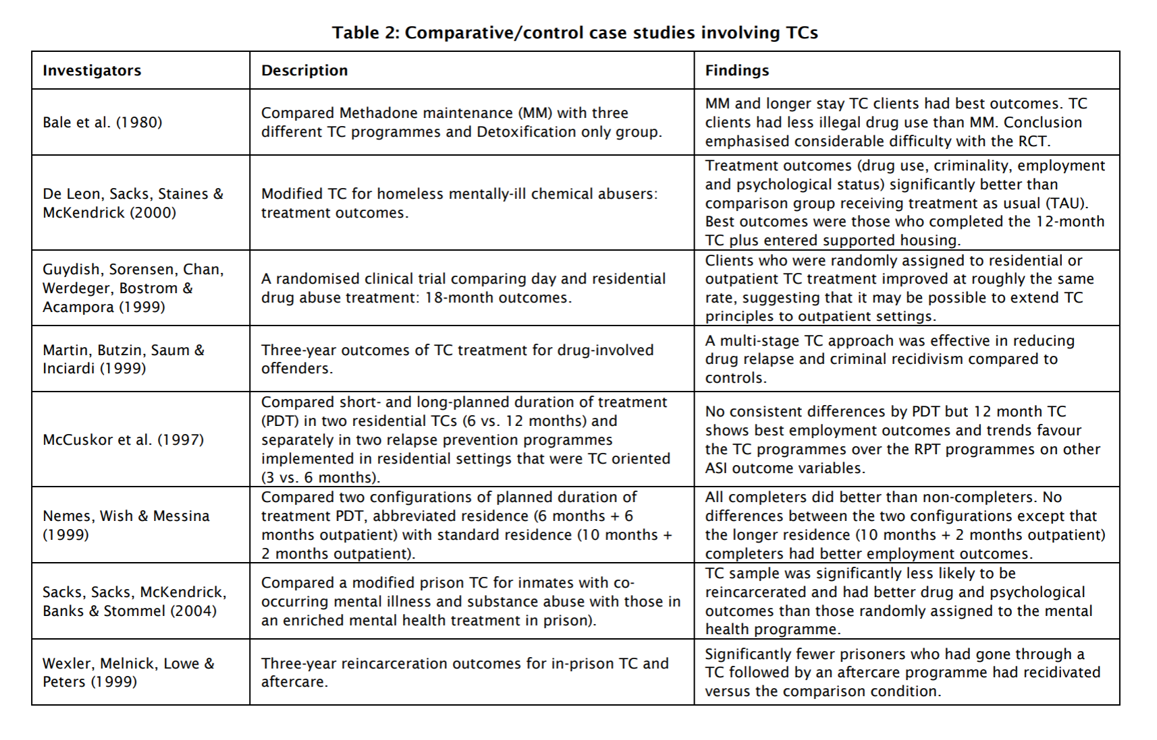

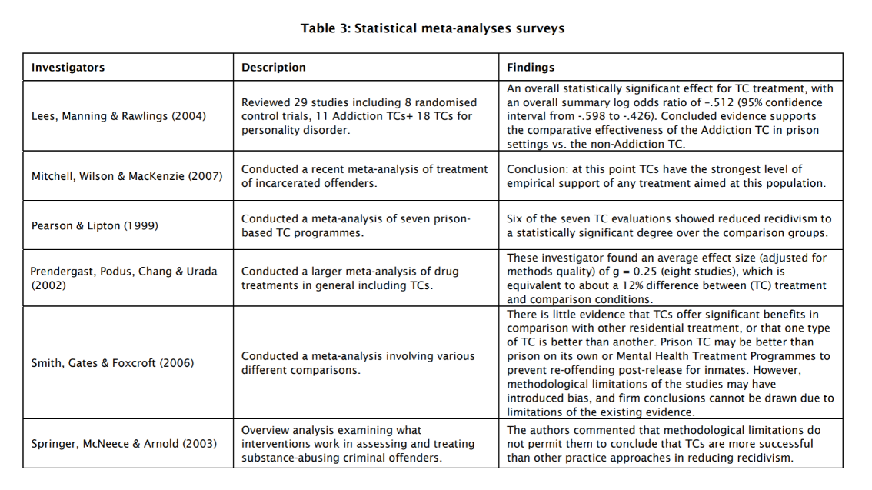
A Compilation of Statistical Meta-Analyses Studies

A Compilation of Cost-benefit Studies
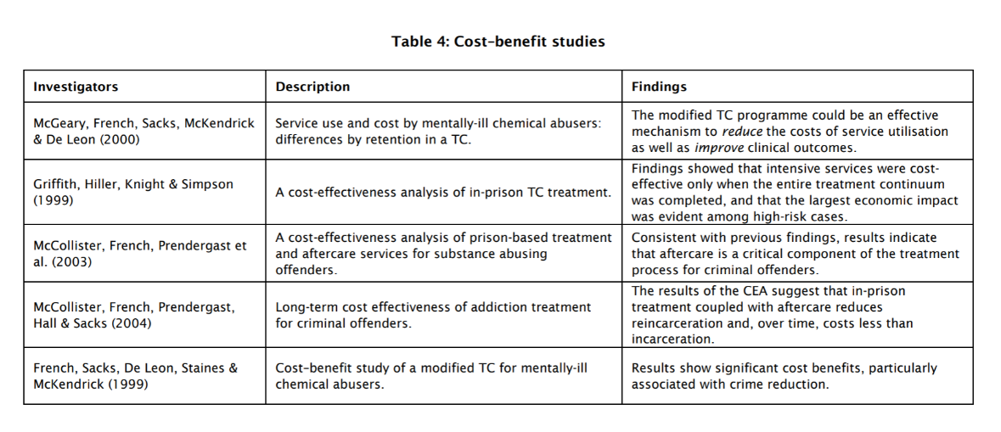

A Compilation Indirect Evidence

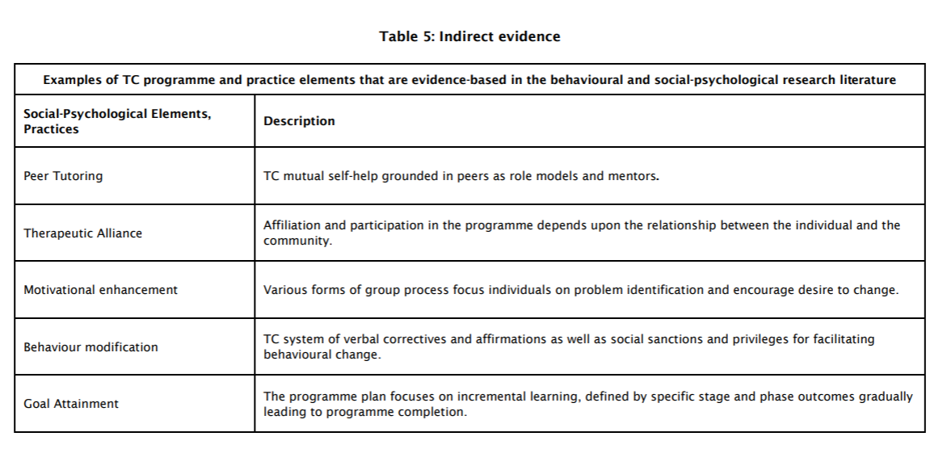
Appendix B:
Selected Annotations of Recent Research

Aslan, L. & Yates, R. (June 2015). Exploring the “black-box” of therapeutic community (TC) methodology and the subjective experiences of students within TC structures. Therapeutic Communities: The International Journal of Therapeutic Communities, Volume 36, Issue 2. https://www.emerald.com/insight/content/doi/10.1108/TC-04-2015-0014/full/html?utm_source=TrendMD&utm_medium=cpc&utm_campaign=Therapeutic_Communities%253A_The_International_Journal_of_Therapeutic_Communities_TrendMD_0&WT.mc_id=Emerald_TrendMD_0.
- “Put simply, we know from 50 years of outcome studies in the field that TCs positively impact upon the lives of those who take up membership in a TC (De Leon, 2010) and we know that the TC is an extraordinarily complex intervention (De Leon, 2000; Yates, 2011) that does not readily lend itself to randomized control trial approaches. What we do not know is the relative importance of the component parts of the TC approach: how they work, how they interact with other elements, whether (and in what way) we could adjust them to make them work better and how clients experience them.”

Aslan, L. (April 2018). Doing Time on a TC: how effective are drug-free therapeutic communities in prison? A review of the literature. Therapeutic Communities: The International Journal of Therapeutic Communities, Volume 39, Issue 1. https://www.emerald.com/insight/content/doi/10.1108/TC-10-2017-0028/full/html.
- “The success of the residential TC model saw these community-led, self-help environments for addicts move into custodial settings and early evidence suggests this transition was effective. The purpose of this paper is to examine the evidence relevant to the effectiveness of prison based, drug-free TCs.”
- “To date, the TC remains superior to other forms of drug treatment in reducing recidivism and drug relapse amongst addicts who offend.”

Best, D. & Haslam, C. (September 2016). Social networks and recovery (SONAR): characteristics of a longitudinal outcome study in five therapeutic communities in Australia. Therapeutic Communities: The International Journal of Therapeutic Communities, Volume 27, Issue 3. https://www.emerald.com/insight/content/doi/10.1108/TC-04-2016-0012/full/html.
- “The paper discusses opportunities for working with social identities both during residence and in community re-integration, and highlights what TCs can do to support and sustain recovery.”

Clarke, J. & Waring, J. (June 2018). The transformative role of interaction rituals within therapeutic communities. Sociology of Health & Illness, Volume 40, Issue 8. https://onlinelibrary.wiley.com/doi/full/10.1111/1467-9566.12773.
- “Interactions that generate feelings of inclusion or exclusion over time are a key component in whether clients gain positive or negative emotional feeling and experience personal change.”

Debaere, V. & Verhaeghe, P. & Vanheule, S. (September 2017). Identity change in a drug-free Therapeutic Community: a Lacanian interpretation of former residents’ perspectives on treatment process and outcome. Therapeutic Communities: The International Journal of Therapeutic Communities, Volume 38, Issue 3. https://www.emerald.com/insight/content/doi/10.1108/TC-01-20170004/full/html?utm_source=TrendMD&utm_medium=cpc&utm_campaign=Therapeutic_Communities%253A_The_International_Journal_of_Therapeutic_Communities_TrendMD_0&WT.mc_id=Emerald_TrendMD_0.
- “The common thread in the participants’ process of change is presented in three parts: their life before, in and after the TC. The substeps within these parts are illustrated with several quotes.”

De Leon, G. (September 2015). “The Gold Standard” and Related Considerations for a Maturing Science of Substance Abuse Treatment. Therapeutic Communities; A Case in Point. Substance Use & Misuse, Volume 50, Issue 8-9. https://www.tandfonline.com/doi/abs/10.3109/10826084.2015.1012846.
- “The randomized control trial (RCT) is commonly celebrated as the “Gold Standard” of research designs. However, such evidentiary distinctions contain serious implications for the scientific acceptance, funding, and public perception of various treatments for substance abuse. This issue and related considerations are briefly discussed from the perspective of therapeutic community treatment and research.”

Vanderplasschen, W. (2013). Therapeutic Communities for Addictions: A Review of Their Effectiveness from a Recovery-Oriented Perspective. The Scientific World Journal, Volume 2013. https://www.ncbi.nlm.nih.gov/pmc/articles/PMC3562581/pdf/TSWJ2013-427817.pdf.
- “Two out of three studies showed significantly better substance use and legal outcomes among TC participants, and five studies found superior employment and psychological functioning. Length of stay in treatment and participation in subsequent aftercare were consistent predictors of recovery status. We conclude that TCs can promote change regarding various outcome categories.”

Yates, R. (June 2010). Cost benefits of therapeutic community programming: Results of a self-funded survey. https://www.researchgate.net/publication/285952000_Cost_benefits_of_therapeutic_community_programming_Results_of_a_self-funded_survey.
- “The study echoed previous research which suggested that treatment interventions of this kind can deliver significant savings to society even where no behaviour change is assumed and only time in treatment is measured against pre-treatment behaviour.”

Therapeutic Communities refer to their participants as clients or residents or students. Within this paper, we will refer to participants of TCs as students.
“New admissions to the TC will commonly be asked by others, ‘What is your problem?’ Their usual reply ‘Dope, I shoot dope’ is invariably countered with ‘That is your symptom, not your problem’” (De Leon, 2000; pg. 39).
Some addicts—particularly those with other mental health conditions—may need a more-chemically focused approach to their addiction; however, these are not the individuals that TCs, including TOSA, focus on.
When we immediately notify the appropriate agencies, generally probation or parole, as well as the local police by phone, email, and text messaging when court-ordered participants leave The Other Side Academy under conditions that violate the terms of their parole or probation.
There is a wide range of resources available to TCs.
All dormitories, showers, and bathrooms are separated by gender.
Some treatment programs are longer or shorter than 2 years. The timeline of phases will reflect the timeframe in which the particular TC is operating within. The program phases outlined in this paper are based upon The Other Side Academy’s structure.
De Leon complied all of the studies done on the TC model in a 2010 research paper. His summaries of each major study can be found in Appendix A.
Appendix B summarizes some of the most recent research on the TC model.

